A/H/P NAS ASSIGNMENT – UNIT 4

# NAME: SOUMYADIPTO DE

# SRN: PES1UG21EC288

# 2ND YEAR, SEMESTER -3

# SECTION: F

**TRANSMISSION PARAMETERS:**

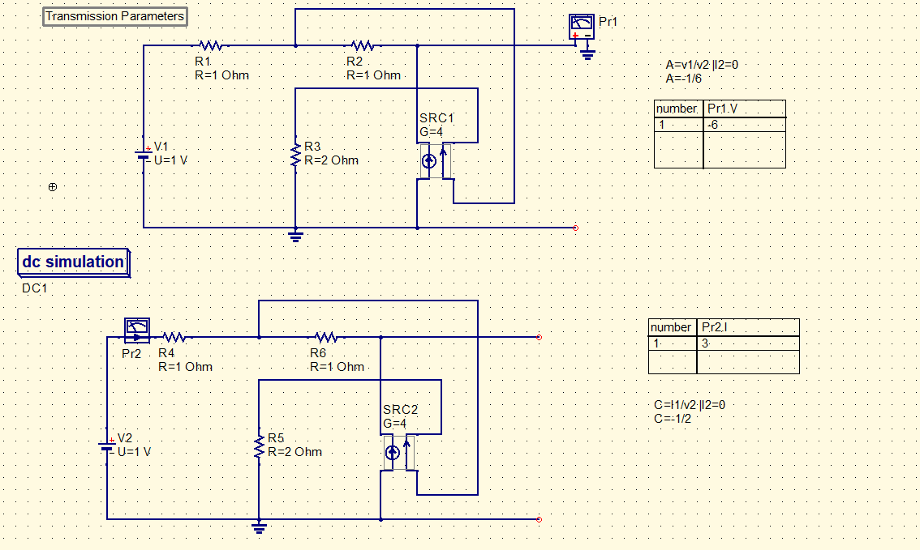

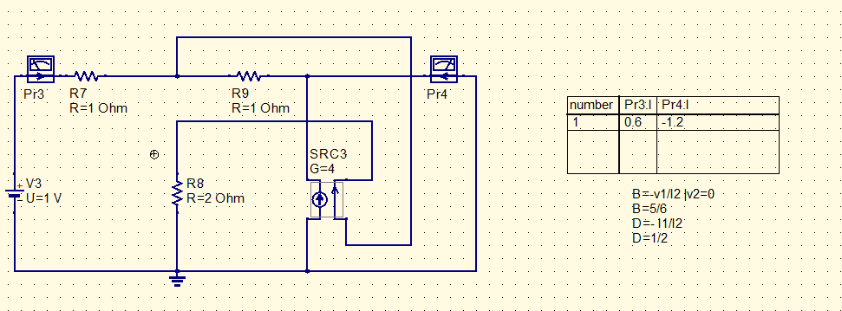

**Z-PARAMETERS:**

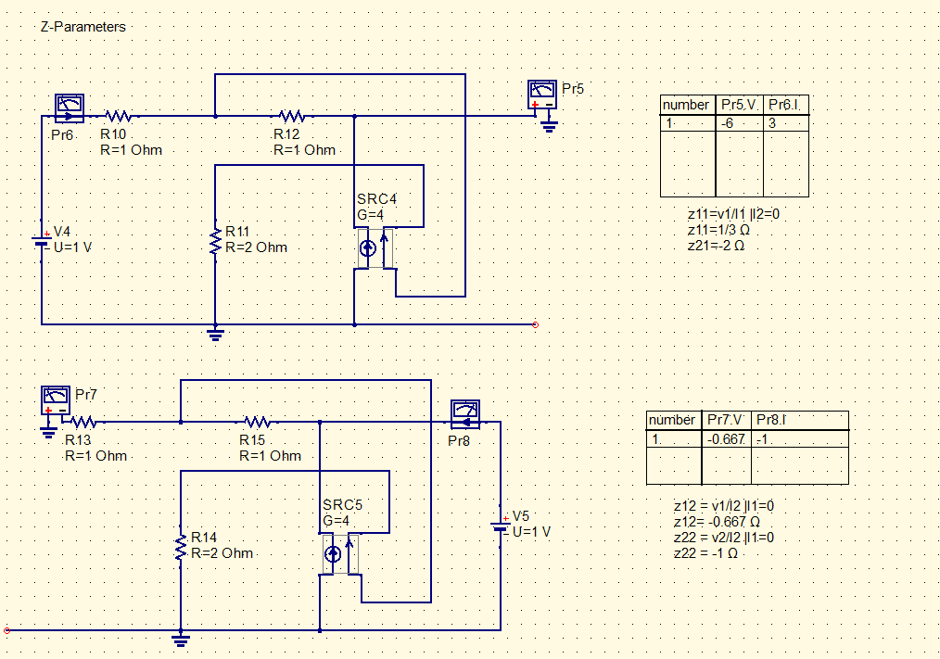

**Y parameters:**

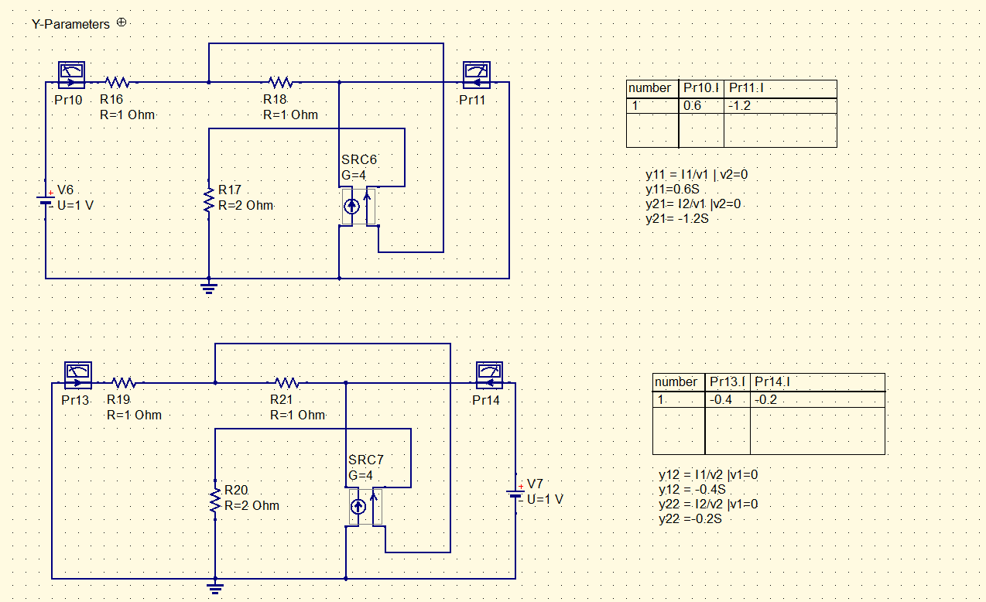

**Hybrid parameters:**

